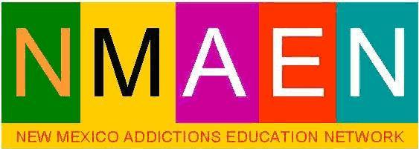

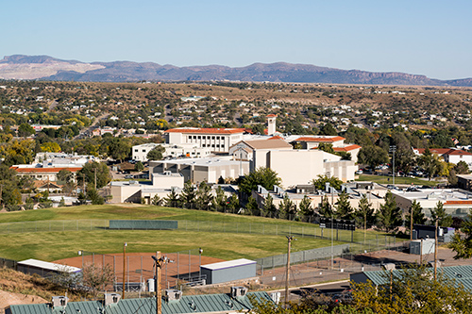
New Mexico Addiction Education Network 57th Annual Institute on Addiction Studies Western New Mexico University July 31 - August 4, 2023 INSTITUTE SCHEDULE (Always subject to change)

57 Years towards the advancement of Recovery and the ongoing development of the addictions treatment workforce… amazing!
A brief look at the Drug Intelligence literature by our colleagues in law enforcement and the criminal justice system suggests the US remains in great peril from the continuing storm of international drug trafficking. India is now posed to be a larger source fentanyl analogs than China, and the number of new compounds are increasing significantly (cf. https://gravesassociates.com).
Yet increasingly our law enforcement colleagues recognize the best hope to stem the epidemic of addiction lies in evidence-based prevention, treatment, and social reforms.
As many people are in recovery in the US as there still in addiction (about 24 million each). Advances in genetics, medicine, psychology, counseling and Social Work yield robust addiction treatment outcomes on par or better, than those of other chronic health problems (heart disease, asthma, hypertension and diabetes) that challenge the whole of society.
Available old and new treatments and more in the near future will continue to provide hope to those persons and communities still mired in addiction
To help our students and workforce prepare for this brave new world, please join us for the 57th Annual Silver City Institute on Addiction Studies. Brought to you by the New Mexico Addiction Education Network and Western New Mexico University.

INSTITUTE SCHEDULE
MONDAY JULY 31, 2023 | JOIN CLASS SESSIONS ONLINE ON ZOOM THE LINK WOLL BE OPEN ABOUT 8:00 AM https://wnmu.zoom.us/j/88599752825 LIMITED DORMATORY HOUSING MAY BE AVAILABLE ($20.00/NIGHT) CALL BOB PHILLIPS (575-208-8737) TO CHECK AVAILABILITY
0730-8:30 AM | Registration in the Besse Forward Conference Center, For Registration for WNMU College Credit contact Dr. Ben Jenkins by Noon Today
8:30-10:00 AM | Welcome and Introductions – Nathan Padilla, LCSW. President, NMAEN  Invocation  Plenary Session,  Plenary Session Continues:  Basic Psychopharmacology, Legalized Cannabis:  In search of the Holy Grail Re-Visited Michael Fraga, PhD
10:00 – 10:15  BREAK | Participants wanting college credit meet with Dr. Ben Jenkins by Noon Today
10:15 - Noon | The Fentanyl Crisis in New Mexico:  Data, Facts, Myths, and Treatment Outcomes  Athena Huckabee, MPH  Ideal Options
Noon to 1:30 | Lunch on Your Own
1:30 – 4:30  Breakout Workshops | The Addictive Process: Dr. John Bourdette | Lifestyles in Recovery  Nathan Padilla, LCSW | ETHICS I  Jennifer Cady, LPCC
6:00 PM til Dusk | Annual NMAEN Potluck Picnic Little Walnut - Gomez Peak Picnic area  BRING GOODIES TO SHARE. NMAEN WILL PROVIDE MAIN DISHES  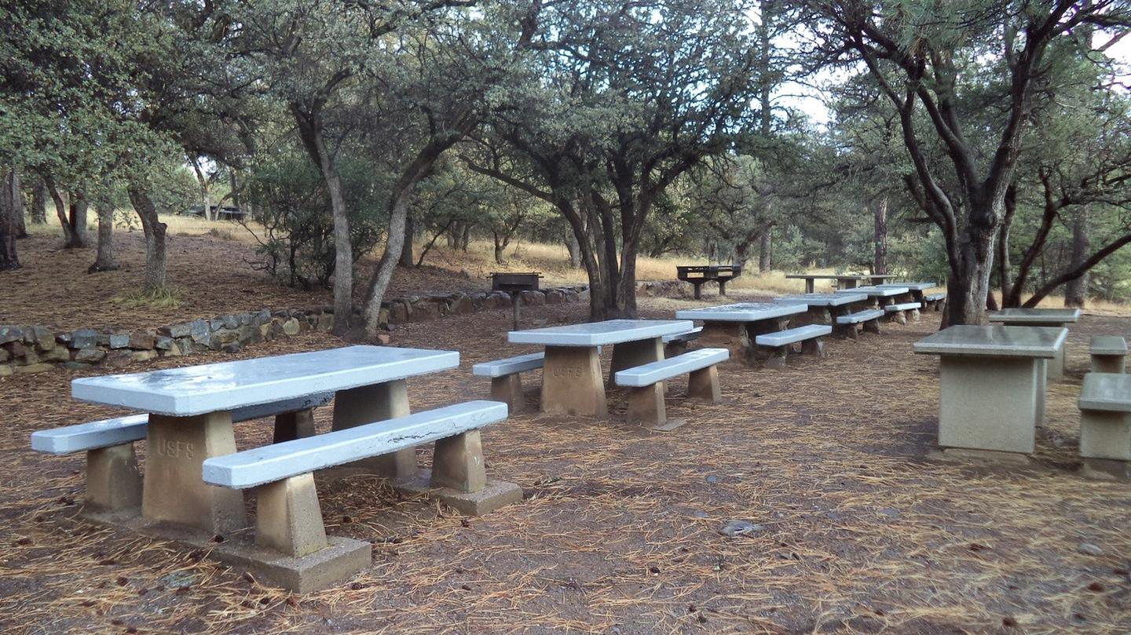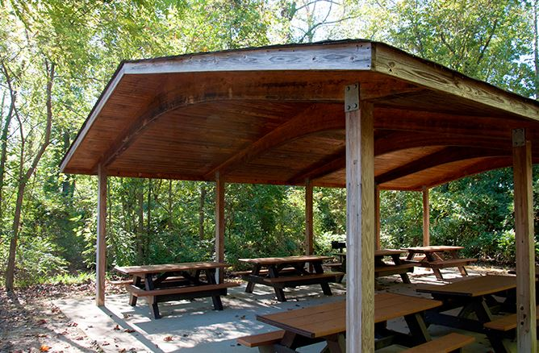
TUESDAY August 1, 2022 | JOIN CLASS SESSIONS ONLINE ON ZOOM THE LINK WOLL BE OPEN ABOUT 8:00 AM https://wnmu.zoom.us/j/88599752825  LIMITED DORMATORY HOUSING MAY BE AVAILABLE ($20.00/NIGHT) CALL BOB PHILLIPS (575-208-8737) TO CHECK AVAILABILITY
0730-8:30 AM | Registration in the Lobby
8:30 – 10:15 AM | Invocation, Welcome and Introductions  John Bourdette, PhD  Addressing Relapse through Evidenced-Based Management of Anxiety, Trauma, Sleep & Depression  Bob Phillips, D.BH
10:15 – 10:30 | Break
10:30 - Noon | Narcan, Overdose Prevention & Overdose Response  Valerie Kling (Ctr. for Health Innovations) & Mark Sanchez (NM Dept. of Health)
NOON-1PM | Lunch on Your Own
1:00 – 2:15  Breakout  Workshops | The Recovery Medicine Wheel  Dr. John Bourdette | Brain Spotting: A new treatment for Rapid Healing  Nathan Padilla, LCSW | An Introduction to Mask-Making  Ron Nestle, LADAC
2:15 -2:30 | Break
2:30 – 4:30  Breakouts  Continue | The Recovery Medicine Wheel  Dr. John Bourdette | Brain Spotting: A new treatment for Rapid Healing  Nathan Padilla, LCSW | Ethics II  Jennifer Cady
EVENING | Socializing , Networking, and Recovery Meetings

WEDNESDAY August 2, 2022 | JOIN CLASS SESSIONS ONLINE ON ZOOM THE LINK WOLL BE OPEN ABOUT 8:00 AM https://wnmu.zoom.us/j/88599752825  LIMITED DORMATORY HOUSING MAY BE AVAILABLE ($20.00/NIGHT) CALL BOB PHILLIPS (575-208-8737) TO CHECK AVAILABILITY
0730-8:30 AM | Registration in the Lobby
8:30 AM-9:00 | Invocation – Balazs Batyka  Orientation for the Sweat Lodge Tonight and Off Campus Activities Available this afternoon & Evening – Michael Villines
9:30 – 9:45 | Break
9:45 – NOON | Helping Clients Understand and Manage Cravings  Dr. Bob Phillips
AFTERNOON ON YOUR OWN

Please enjoy our traditional time of Rest and Relaxation on Wednesday afternoon of the Institute. There is much to see, experience and enjoy in Silver City, including the Ron Nestle Invitational / Michael Fritz & Bubba Long Memorial Golf Tournament, the Million Bones Project, a trip to Faywood Hot Springs, ClayFest exhibits, Galleries and great places to shop and eat!

5:30 PM | PREPARATION AND DEPARTURE FOR THE SWEAT LODGE  Meet in front on the Global Resource Center to caravan to the Sweat Lodge

THURSDAY  August 3, 2022 | JOIN CLASS SESSIONS ONLINE ON ZOOM THE LINK WOLL BE OPEN ABOUT 8:00 AM https://wnmu.zoom.us/j/88599752825  LIMITED DORMATORY HOUSING MAY BE AVAILABLE ($20.00/NIGHT) CALL BOB PHILLIPS (575-208-8737) TO CHECK AVAILABILITY
0730-8:30 AM | Registration in the Lobby
8:30 – 9:00 AM | Invocation Announcements and Introductions of Speakers – Nathan Padilla
9:00 – 9:15 | BREAK
9:30 - Noon | Plenary Session  An Update on New Mexico Legislation impacting Addictions and Treatment  Bob Phillips, D,BH  Psychopharmacology  Dr. Michael Fraga
Noon – 1: 30PM | Lunch on Your Own
1:30 – 4:00  Breakout  Session  Workshops | Spirituality and Restorative Justice  Balazs Batyka & Henry Dickson, Esq | Planning for a Successful Retirement  John Bourdette, PhD | Supervisory  Methods  Jennifer Cady, LPCC
BREAK
4:30 – 6:00 pm | NMAEN ANNUAL MEETING AND BOARD ELECTIONS  SEE INSTRUCTIONS FOR CERTIFICATES AND CEUs BELOW
FRIDAY August 4, 2022 | JOIN CLASS SESSIONS ONLINE ON ZOOM THE LINK WOLL BE OPEN ABOUT 8:00 AM https://wnmu.zoom.us/j/88599752825  Counseling Ethics 6.0 hrs  ANNUAL 6 HOURS OF ETHICS TRAINING or SUPERVISION ETHICS  Jennifer Cady & Bob Phillips
0730-8:30 AM | Registration in the Lobby
TO GET CEUs and CERTIFICATE OF ATTENDANCE GO OUR WEBSITE. DOWNLOAD AND FILL OUT THE CEU RECORD FORM AND SUBMIT IT PER THE INSTRUCTIONS ON THE FORM Thanks for joining us! Have safe travels and we’ll see you next year!
WWW.SILVERCITYINSTITUTE.ORG
For questions or more information call Bob Phillips at (575) 208-8737 57th Annual Silver City Institute - Board and Planning Committee (Join US!)
Nathan Padilla
Balazs Batyka
Bob Phillips
Michael Fraga
Maria Fairclough
John Baldonado
John Bourdette
Jennifer Cady
Ben Jenkins

